NokiaTsy Test Tool Functional Specification

Telephony Services Technology Team

Owner | Oula Aikio
Document ID: | <If you maintain your document elsewhere than DocMan, please ask your PIMS to get you one from EDMS>
Function: | TP/AP/SPP/CASW/TSTT
Approver: | Susanna Ollonen

Location - Continuus |  | Location - Lotus Notes
Engine host: | ouccm15 | Database: | TSW DocMan
Database path: | /opt/ccm_dbs/ou_media | Server: | Eslns40/SRV/Nokia
Project: | TEFDocs | LN Filename: | NMP\MSW\TSW\tswdm.nsf

Copyright © 2004 Nokia. This material, including documentation and any related computer programs, is protected by copyright controlled by Nokia. All rights are reserved. Copying, including reproducing, storing, adapting or translating, any or all of this material requires the prior written consent of Nokia. This material also contains confidential information, which may not be disclosed to others without the prior written consent of Nokia.

Contents
1. Overview 5
1.1 Introduction 5
1.2 Scope and utilization 5
1.3 General Notes 5
2. General Usage 7
2.1 What is NokiaTsy Test Tool ? 7
2.2 How is NokiaTsy Test Tool used ? 7
2.2.1 STIF SERIES 60 UI 7
2.2.2 STIF Console UI 7
2.2.3 ATS 7
3. User Interfaces 8
3.1 STIF SERIES 60 UI 8
3.2 STIF Console UI 8
3.3 ATS UI 9
4. NokiaTsy Test Tool Functional Specification 10
4.1 Introduction 10
5. Design principles 11
5.1 STIF TestFramework and NokiaTsy Test Tool big picture 11
5.2 NokiaTsy Test Tool and TestScripter Module 12
6. References 13
Document References 13
Book and Other References 13
Lotus Notes Database References 14

Change History
Version | : | 1.0
Status | : | Approved
Date | : | 31-May-2005
Author | : | Oula Aikio
Comments | : | Approved in inspection TSW ActionDB id: EO05031657456

Version | : | 0.2
Status | : | Draft
Date | : | 17-Mar-2005
Author | : | Oula Aikio
Comments | : | Corrections made according to inspection comments

Version | : | 0.1
Status | : | Draft
Date | : | 15-Feb-2005
Author | : | Oula Aikio
Comments | : | Initial draft

Terms and Definitions

Abbreviation | Description
AP | Application Platform
CASW | CellMo Adaptation Software
GUI | Graphical user interface
SPP | Symbian Product Platform
STIF | Name of the developed test tool
STIF ATS interface | The Console application of STIF Test Framework for running test cases automatically
STIF Console UI | The Console application of STIF Test Framework
STIF SERIES 60 UI | The GUI application of STIF Test Framework
TP | Technology Platform
TSTT | Telephony Services Technology Team
TSY | Telephony system
UI | User interface

Overview

Introduction
This document describes the concept of NokiaTsy Test Tool. Test Tool works as a part of STIF Test Framework.

Scope and utilization
This functional specification details the common functionality of NokiaTsy TestTool module testing component.

General Notes
This document may also refer to various other NMP documents, Lotus Notes databases, published books, and other documents.
NMP document references will be marked by notation /D.X/ Document Name, and details of the references can be found in section Error: Reference source not found.
References to Lotus Notes databases will be marked by notation /LN.X/ Database Name, and the list of databases can be found in section Error: Reference source not found.
Book references will be marked by notation /R.X/ Book Name, and details of the references (author, ISBN, etc.) can be found in section Error: Reference source not found.
Other references will be marked by notation /R.X/ Title, and details of the references can be found in section Error: Reference source not found.

General Usage
This chapter describes NokiaTsy test tool’s different usage options.

2.1 What is NokiaTsy Test Tool ?
NokiaTsy TestTool is testing software that is running in STIF Test Framework. TestTool’s purpose is to test NokiaTsy (Licensee specific TSY) via CommonTsy –plug in API.

2.2 How is NokiaTsy Test Tool used ?
NokiaTsyTest Tool can be operated in three different UI’s / stages.

2.2.1 STIF SERIES 60 UI
User can do testing so that STIFTestFrameworkGUI.sis is installed as a S60 application and necessary NokiaTsyTestTool –dlls (at least Core.dll and Notify.dll) are loaded for example to mmc-card. STIF Test Framework will detect TestTool dlls and user can begin testing after TSY – test cases is shown to FrameWork’s UI.

2.2.2 STIF Console UI
If Development environment does not offer STIF SERIES 60 UI (NCP2 and BSP – environments) user can use STIF Test Framework’s STIF Console UI. After user has started ConsoleUI.exe (using keyboard in emulator or using autoexec.bat and testframework.ini –file in the hardware) he or she can start testing using simple ConsoleUI –users interface.

2.2.3 ATS
ATS Interface is a console application that takes command line parameters to control the test framework, for example the used test module.

User Interfaces
There are three main ways of incorporating NokiaTsy TestTool into the UI. Three simple examples of different UI’s are shown below.

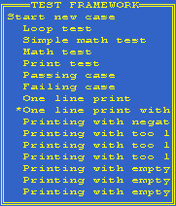
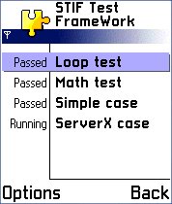
STIF Console UI: STIF SERIES 60 UI:

STIF ATS Interface
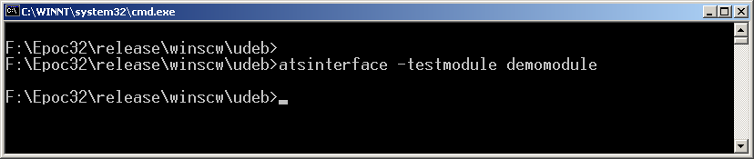

3.1 STIF SERIES 60 UI
The user can load different test modules, test sets and scripts via STIF SERIES 60 UI. User can execute test parallel, serial or select necessary test from menu view. TestFramework writes log-files for example to a mmc – card.

3.2 STIF Console UI
User can navigate ConsoleUI from phone’s navi key. If user want to select some test case then he / she moves navi key to right position. This action means the same than pressing enter. If User wants to go back in a menu then he / she moves navi key to left position.

User can execute tests parallel, serial or select necessary test(s) from menu view.
ConsoleUI writes log –files for example to a mmc-card or if emulator is used to c –drive (c:\logs\).

3.3 STIF ATS Interface
STIF ATS interface can be used for running test cases when UI is not needed or it cannot be used.
Execution result can be checked e.g. from xml result file in c:\Testframework\xml\
ATS can be executed from command line in emulator or from EShell in hardware.

4. NokiaTsy Test Tool Functional Specification

4.1 Introduction
NokiaTsy TestTool is a set of test modules which are running in STIF Test Framework. TestTool’s purpose is to test NokiaTsy (Licensee specific TSY) via CommonTsy –plug in API.
NokiaTsyTestTool will have following test modules:

- Core.dll
- Notify.dll
- VoiceCore.dll
- Voice.dll
- SMS.dll
- NWE.dll

Above mentioned dll’s will use following test script –files:

- Core.cfg
- Voice.cfg
- SMS.cfg
- NWE.cfg

NokiaTsy Test Tool will use two different test modules: TestScripter, provided by STIF Test Framework and VoiceTestModule provided by NokiaTsy TestTool.

Design principles
Here are described NokiaTsy Test tool’s main design principles.

5.1 STIF TestFramework and NokiaTsy Test Tool big picture
In the picture below is described how NokiaTsy Test tool is linked to STIF TestFramework. Picture consist all the functionality that can be used via STIF Test Framework. NokiaTsy Test Tool’s testmodules are so called testclasses which can be generated using test module creation wizard.

Tsy Test Tool uses Test Scripter module which parses test case file and executes script line by line. All test case specific functionality is implemented to XXXBlocks.cpp –file. See picture x:

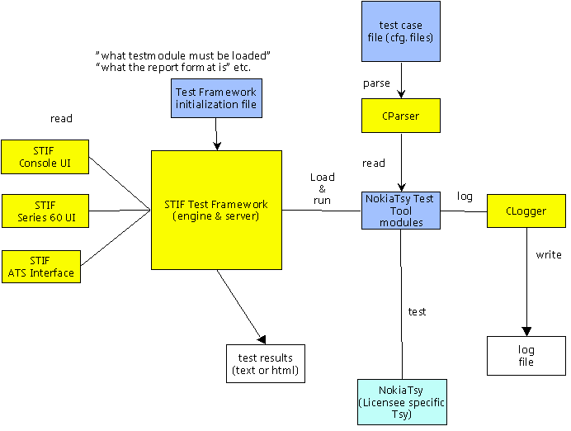

5.2 NokiaTsy Test Tool and TestScripter Module
Test Tool uses TestScripter module which parses test case file and executes script line by line. All test case specific functionality is implemented to Test classes. For example Voice –test class has two cpp –files, voice.cpp and voiceblocks.cpp and one header –file, voice.h.

